WINTER WORKSHOP
2012
Kim Morrissey
Physical Education Teacher
Dodge Literacy Magnet
kmorrissey@usd259.net

MOVEMENT ENHANCES LEARNING
“Physical Activity may increase student performance.” Ratey
“Physical activity is good not only for the heart, but also for the brain, feeding it glucose and oxygen, and increasing nerve connections, all of which makes it easier for children of all ages to learn. Numerous studies show that children who exercise do better in school.” Newsweek, 2/19/96
Linking MOVEMENT to LEARNING
According to Harvard clinical psychiatry professor Dr. John Ratey, what makes us move is also what makes us think. Certain kinds of exercise can produce chemical alterations that give us stronger, healthier, and happier brains. A better brain is better equipped to think, remember, and learn.
- Bodily Kinesthetic is one of eight Multiple Intelligences. (Gardner)
- Most students, up to 85%, are pre-dominantly kinesthetic learners. (Hannaford) Children in poverty seem to rely primarily on their kinesthetic abilities for learning. (Payne)
- Repetitive Gross Motor movement balances brain chemicals that calm behavior and elevates self-esteem and self worth, accommodates ADD/ ADHD. (Jensen)
- Motor skills are fundamental to learning. Memory is retrieved better when learned through movement. (Jensen)
- Heart-Brain Entrainment - The heart and the brain work together for learning. (Hannaford)
- Learning happens throughout the body. The body is the unconscious mind. (Pert)
- Movement is the body’s natural reward system. (Jensen)
- Crossing the midline integrates the brain to organize itself. Neural activation occurs to many parts of the brain and equally to both hemispheres, making the brain more alert and energized for learning. (Dennison)
- Improved balance improves spatial skills needed to read letters left to right on a page.
- Beat awareness and beat competency enhances the internal dialogue for better silent reading. (Weikart, Campbell, Campbell)
- Physical activity that navigates the environment promotes eye fitness needed for reading.
- Exercise reduces stress by lowering cortisol levels that kill brain cells.
- Exercise has the same effect and benefit as anti-depressant medications. (Ratey)
- Exercise may boost brain function, improve mood, and increase learning. (Ratey)
- Vigorous exercise has been shown to improve behavior, mental focus, and memory retention of ADHD students. (Wendt)
- Lifetime physical activity grows new brain cells. (Gage)
- People who are most aerobically fit have the fastest cognitive responses. (Van Praag)
- Physically active people report an increase in academic abilities, memory, retrieval, and cognitive abilities. (Ratey)
Using movement in the learning process helps many children retain and retrieve information more efficiently. Physical activity prepares the brain for learning by providing a healthier body/brain that works more effectively. All things being equal, healthy active students can learn better.
Preparing the brain for learning
SET THE PACE
An important consideration for both movement and learning is hydration. Many children do not drink enough water during the day. Begin each lesson by having the students drink some water. Provide additional water breaks so that students are encouraged to drink water as often as they want. Remember: The brain is about 85% water and water is a natural conductor of electricity. Without water, the body has to work harder at almost everything including learning.
The PACE process is a four-step learning readiness tool created by educator Paul E. Dennison, Ph.D., and his wife and partner Gail E. Dennison. PACE is one part of a comprehensive movement-based learning program called Brain Gym®. *
PACE stands for
P = Positive: Hook-ups
A = Active: Cross Crawl
C = Clear: Brain Buttons
E = Energetic: Water
The PACE PROCESS:
We each have our own pace—a unique rhythm and timing for learning. The PACE activities help us to rediscover that rhythm. Students can notice if they feel positive, active, clear, and energetic, and do the corresponding movements as needed. Perform PACE in reverse order from E to P.
E = Energize for learning, by drinking water to hydrate the brain. Encourage to sip water often. The brain is about 85% water and water is a natural conductor of electricity. Each neuron sends out an electrical response when one cell communicates to the other. About 10 minutes after drinking water, there can be better retention and retrieval of memory.
C = Clear the mind with Brain Buttons, by increasing circulation to the brain and relieving visual stress. Find the indentations just below the collarbone to the left and right of the Sternum (directly below the eyes). These are your Brain Buttons. Massage this area with your index finger and your thumb and put your other hand on your belt buckle.
A = Activate the body with Cross Crawl to increase circulation and cross the visual/kinesthetic midline. Cross Crawls simultaneously activates the right and left cerebral hemispheres.
Cross Crawl uses the same neural connections as the brain requires for reading, writing, and math processes. Activities that cross the midline strengthen and prepare the brain for learning.
P = Positive experience results when we do the Hook-ups. This activity brings circulation to the frontal lobes—the thinking center of the brain. Hook-ups restore equilibrium after emotional or environmental stress.
Cue words: "Hands out; thumbs up, clap and miss, thumbs down, clap backwards until palms touch. Pretend thumbs are an ice cream scoop and scoop up the ice cream under your chin."Hold this position. When the student is ready, the student uncrosses the legs and touches fingertips of both hands together continuing to breathe deeply.
* Brain Gym® is a registered trademark of the Educational Kinesiology Foundation, www.braingym.org

Perform one or two movements at the start of every lesson to prepare children to learn. The Brain Gym® activities are also effective for calming students down after a more vigorous activity.

Keep It Short: 5 to 10 Minute Activity Breaks
Try to avoid having students engage in academic work for more than 60 minutes at a time.
Establish a signal for students to stop what they are doing and get ready for an activity break.
Establish a different signal that lets students know to wrap up an activity break and return to their work.

BRAIN JOGGERS

CELEBRATE - HUG: For the younger students, start with the Celebrate - Hug. With straight arms, shake your hands above your head. Then cross the arms over the chest as if you are hugging your shoulders.
BRAIN BUTTONS: Place one hand over the navel and the other hand gently massages the space between the first and second ribs under the collarbone.
CROSS CRAWL: Standing in a “walking” motion, lift the right knee slowly and bring the left hand to gently touch the right knee. Alternate by bringing the right hand to gently touch the left knee. Repeat. Perform this movement slowly.
HOOK-UPS: Hook Ups can be done while sitting, standing, or lying down. Cross the legs comfortably at the ankles. Next, cross the arms at the wrists (palms of the hands facing) and join the fingers together. Bring the hands down and then under the arms, now rest the hands under the chin. Finally, rest the tongue on the roof of the mouth. This position is recommended for students experiencing stress. Cue words: “Hands out; thumbs up, clap and miss, thumbs down, clap backwards until palms touch. Pretend thumbs are an ice cream scoop and scoop the ice cream up under your chin.” Hold this position. When the student is ready, the student uncrosses the legs and touches fingertips of both hands together continuing to breathe deeply.
LAZY 8’s FOR EYES: Hold the thumb at eye level in the middle of the body, elbow length from the eyes. Move the thumb slowly, following its motion with the eyes. Move in the following pattern: Up the center of the body to the top of the visual field, up and over to the left, around and down in a counterclockwise pattern. As the thumb returns to the center, bring it back up the midline and then clockwise – out, around, and down to the right side. Repeat, slowly, at least three to five times with each hand. Next clasp hands together with the thumbs forming an “X” and perform the Lazy 8s with hands together. For a variation use a streamer made from a ribbon attached to a pencil eraser with a thumbtack.
THE ELEPHANT: Touch the left ear to the left shoulder, tight enough to hold a piece of paper, and extend the left arm like a trunk. Relax the knees and draw the Lazy 8 pattern in the mid-field, starting up in the middle, then out and around. The eyes follow the movement, focusing past the fingertips to an imaginary 8 on the wall. Repeat the pattern at least three to five times and then repeat with the right hand.
THE THINKING CAP: Unroll the outer ear from the top to the bottom using the index finger and the thumb, several times.

CROSS LATERAL MOVEMENT PROGRESSIONS
Cross Crawls: Touch the right elbow to the raised left knee. Switch.
The Windmills: Bend down to cross over and touch the right foot with the left hand. Bend the knees slightly as you touch the foot. Stand up. Switch to touch left foot with right hand.
Slapping leather: Stand up straight. Reach behind you with your right hand and touch the left heel as your leg is bent up behind you. Stand on both feet. Repeat to the opposite side.
Grapevine: Step to the right on the right foot. Cross the left foot to step behind the right foot. Step on the right foot to the right. Kick the left foot out in the front. Say “Step, behind, step, kick”.
Karaoke: Continue the grapevine step by not kicking the left foot out in front, but instead, by stepping on the left foot in front of the right foot to continue twisting to the right. Say “Step, behind, step, cross”
Straddle Cross: Start with hands at sides and feet together. Jump to feet apart. Jump to feet crossed right over left. Jump to feet apart. Jump to feet crossed left over right. Repeat.
Hand Clap Patterns: Students face a partner. Slap hands on thighs twice. Clap hands together twice. Slap partner’s hands twice. Clap twice. Repeat to rhythm of song or music. Variation: Cross over to slap right hands then left hands in patty-cake fashion.
Hand Jive Pattern: Clap thighs twice. Clap hands twice. With palms down, cross right hand over left twice and then left over right twice. Pound right fist twice on top of left fist, and then pound left fist twice on top of right fist. Shake right thumb twice over the right shoulder like a hitchhiker and then shake left thumb over the left shoulder (hitchhiker)
Slap Count: Partner #1 starts by gently slapping his/her right hand into the right palm of partner #2 and then the left hand into the partner #2’s left palm, keeping a steady beat. Then partner #2 slaps the right then left palms of partner #1. Say “1-2-3-4, etc.” Count out loud in rhythm 1-25.Now skip count using the same right- left- right- left slap pattern counting by 3’s, then 6’s, 9’s, etc. (Multiplication tables). Challenge yourself by skip counting any number.
Slap Spell: Partner #1 slaps his/her name 2 letters at a time into the palms of partner #2 and partner #2 spells hi/her name 2 letters at a time into the palms of partner #1 using the same slapping pattern as before. Notice how much harder your brain has to work to not think about what your partner is spelling.
Variation: Each partner thinks of a spelling word but doesn’t tell his/her partner what it is. Using the same slap pattern, each partner slaps out his/her word. When finished, partner #1 has to try to tell partner #2 his/her word, and vice versa.
Inside/Outside Circle: Divide the class in half. One half of the class will make up the inner circle and will have their backs towards the middle of the circle. The other half will make up the outside circle and will be facing someone in the inner circle. This activity can be used as an ice breaker or as a review for an exam. Students introduce themselves to their partner. The teacher asks a question or gives a task to be completed. Allow time for discussion or completion of task. Inside circle rotates one, two or three people to the right. Students introduce themselves to the new partner and wait for the next task.
Elicit a Physical Response: Get ‘Em Moving!: If these words end with a /t/, then… If they end with a /m/, then…. If these words rhyme, then ….. If they don’t, then …. If these words start the same, then …. If they don’t, then …..

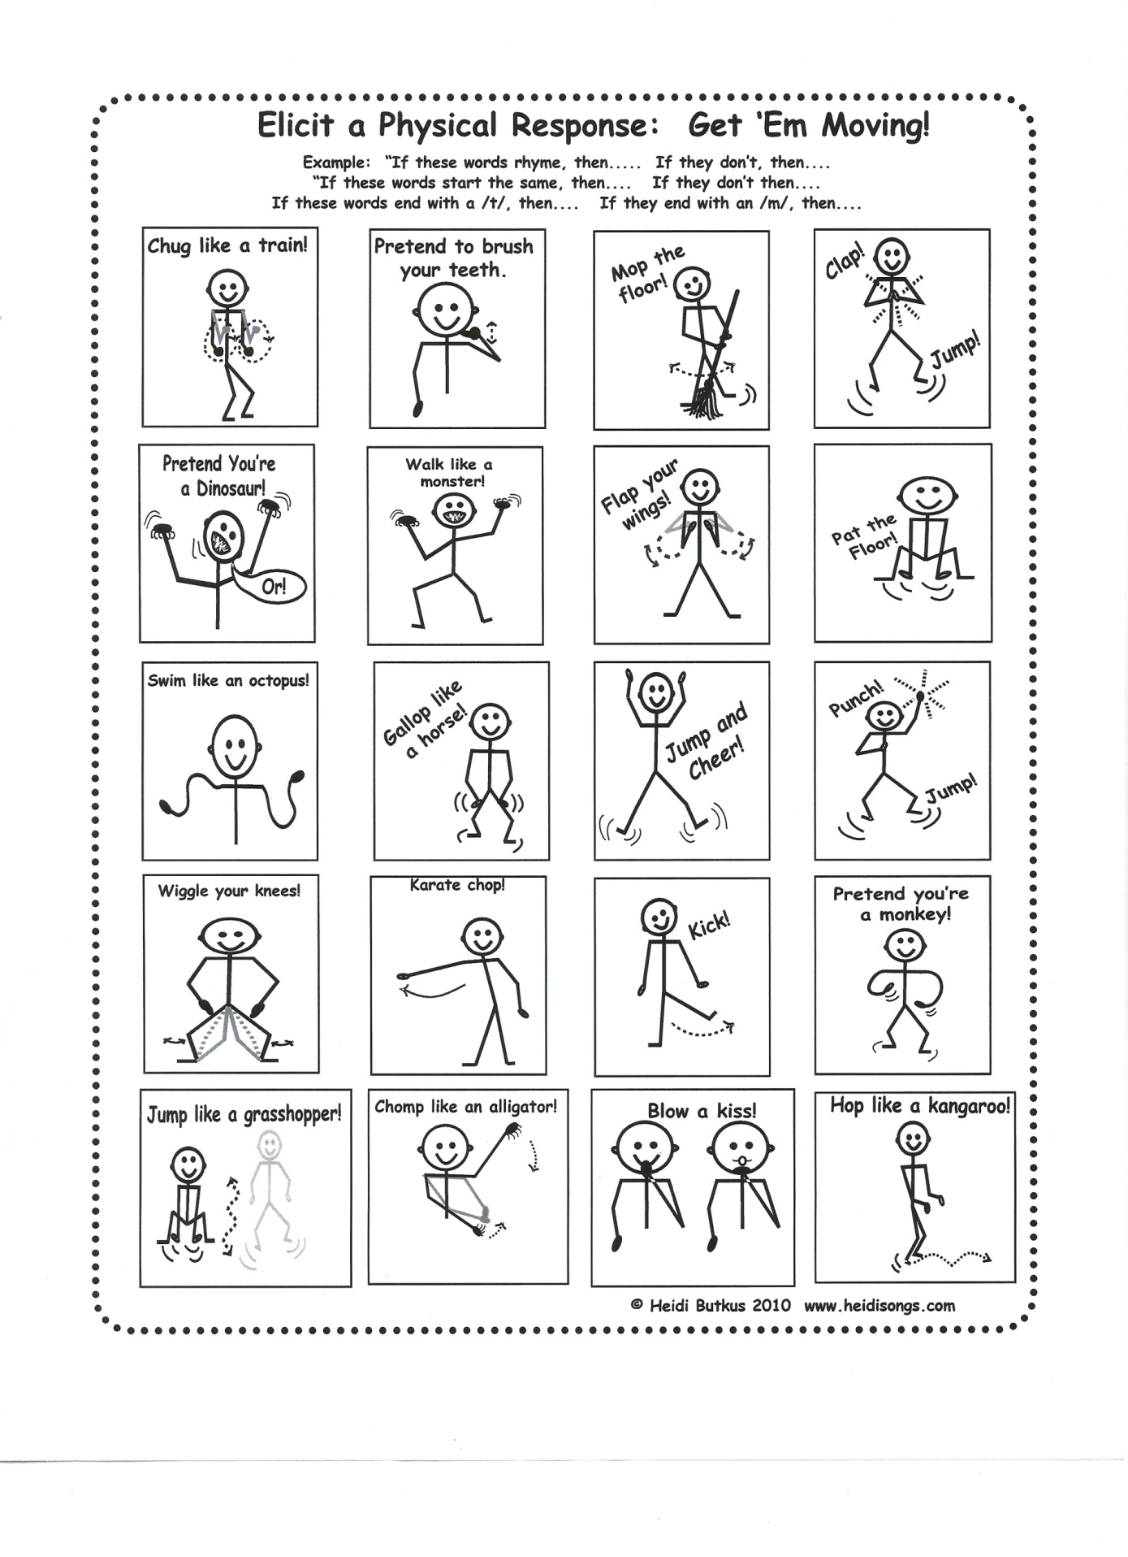
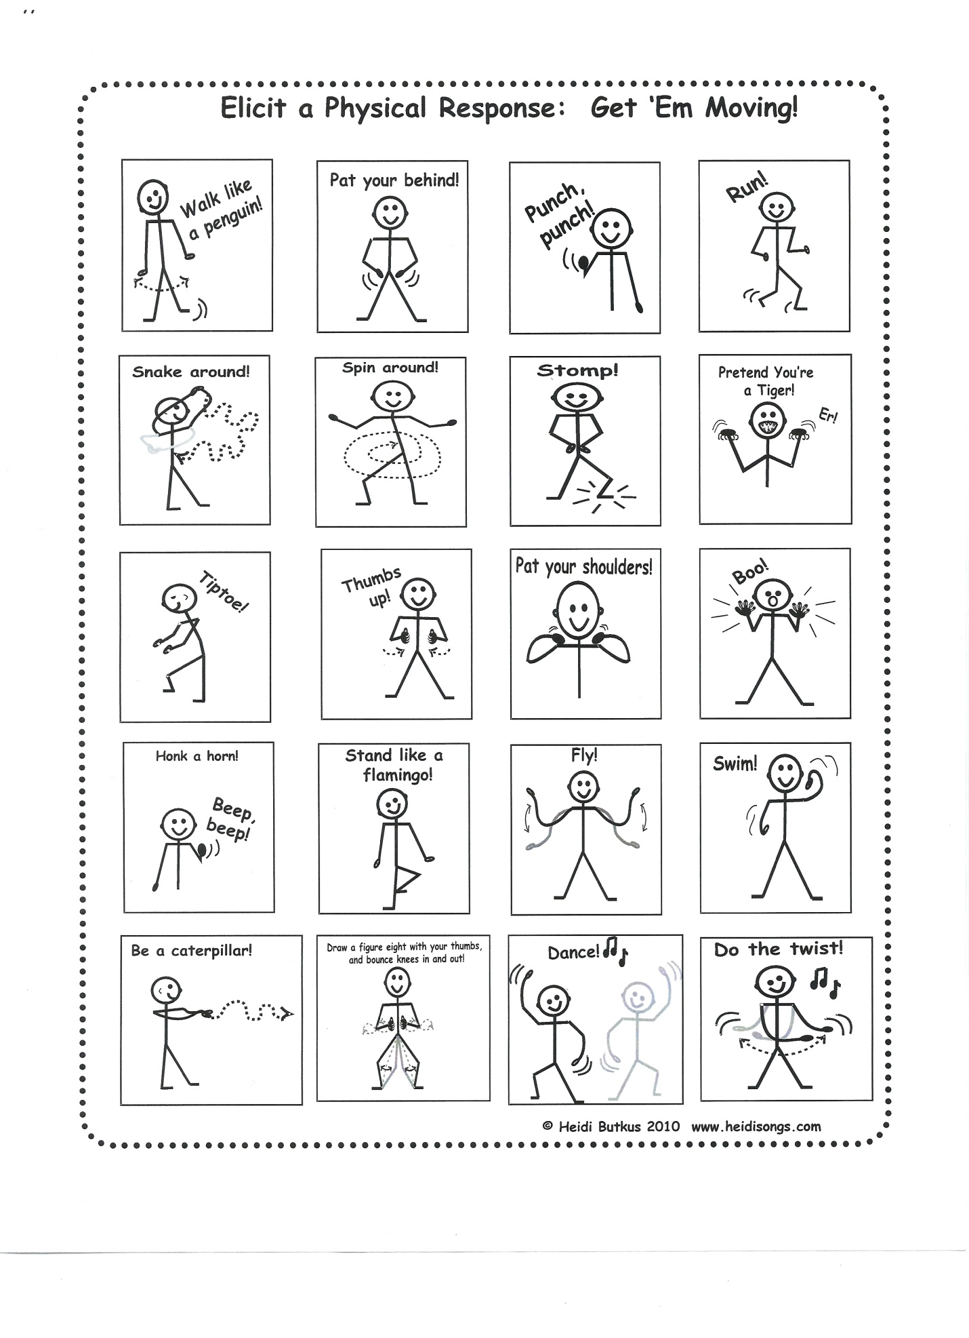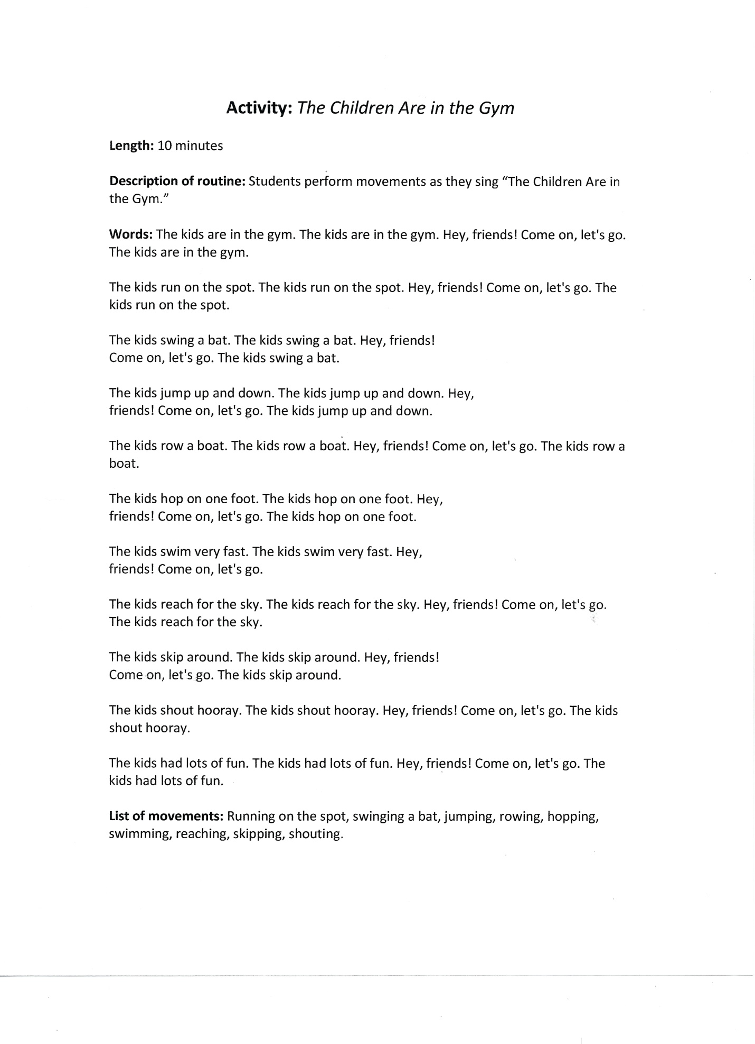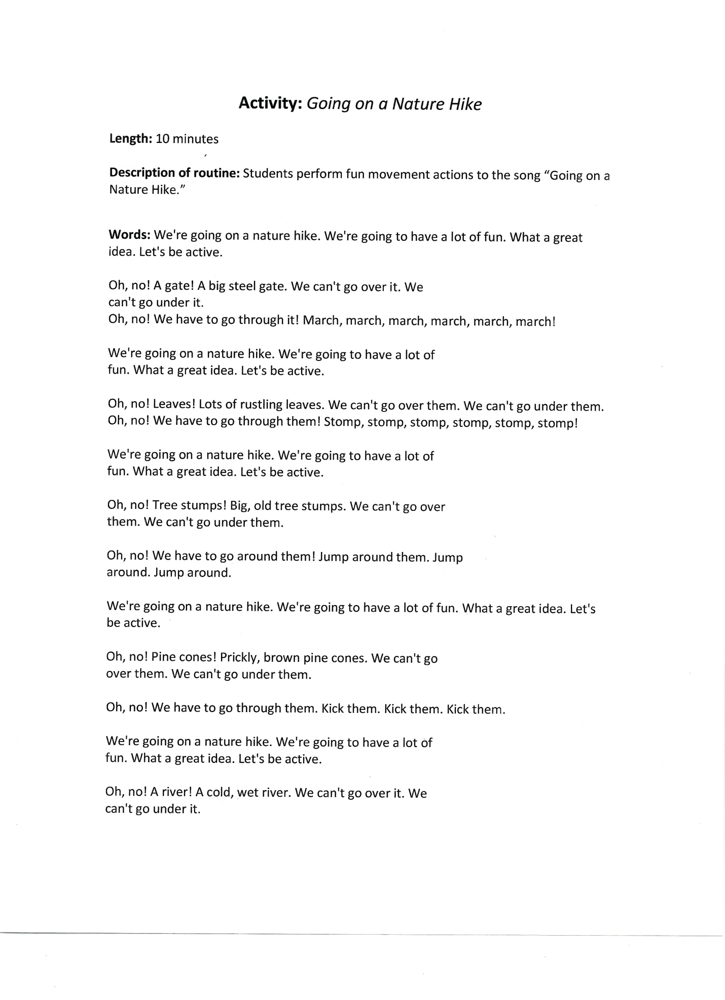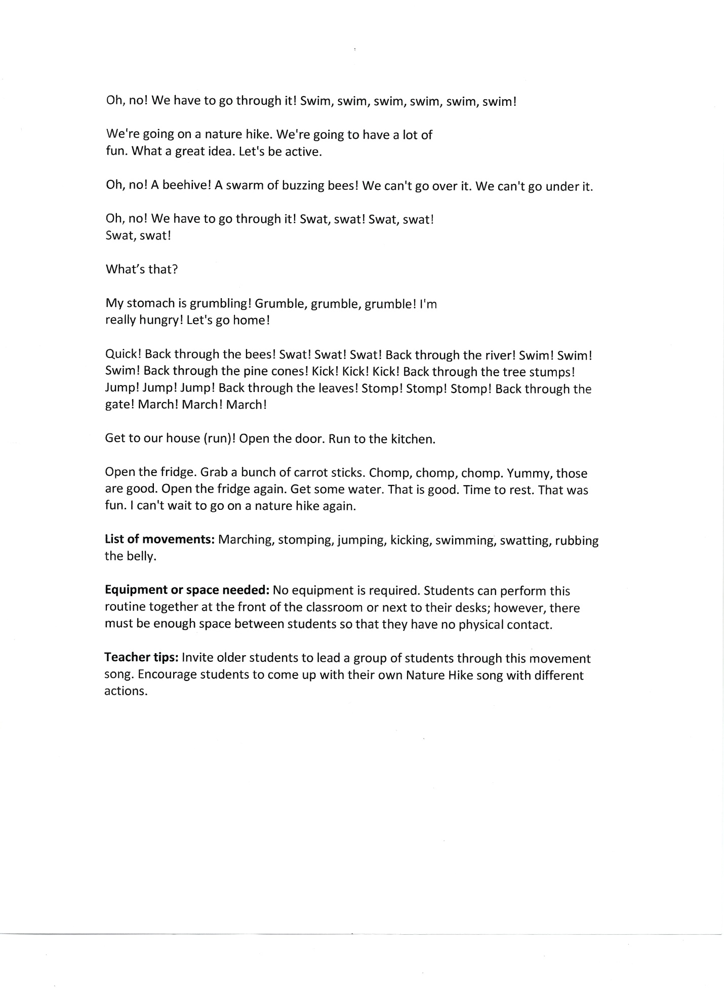

Heart Smart (K-2): Teacher discusses the heart:
- Where is it located? Left side of the chest.
- What size is it? Size of a fist.
- Function? Deliver blood to the body.
- What strengthens the heart? Jumping, swimming, jogging.
- What weakens the heart? Inactivity, smoking, unhealthy diet.
Teacher calls out a habit that strengthens or weakens the heart. If the habit strengthens the heart, students will respond by jumping for 15 seconds. If the habit weakens the heart, students will respond by falling down or squatting for 5 seconds.
- Riding a bike – jump
- Eating 4 pepperoni pizzas – fall
- Walking your dog – jump
- Smoking cigarettes – fall
- Never going outside to play and watching TV all the time – fall
- Dancing with your friends – jump
- Skating – jump
- Never eating fruits/vegetables – fall
- Riding a scooter – jump
- Shooting baskets – jump
- Playing video games – fall
- Eating fast food – fall
- Raking the leaves – jump
- Washing the car – jump
- Taking the stairs – jump
- Taking the elevator – fall
- Swimming – jump
- Eating potato chips and Twinkies – fall
Hit The Deck (2-5): Teacher places the deck of cards in front of the class. Have one student select a card and students will do the corresponding activity for each suit. It helps to write the activities on the board for each suit:
- Hearts: touch elbow to knee or crunches for 20 seconds
- Diamonds: jog in place or march in place for 20 seconds
- Clubs: modified push-ups or cabbage patch dance for 20 seconds
- Spades: jumping jacks or scissor jumps for 20 seconds.
Provide other students opportunity to pick a card from the deck and repeat activity.
Air Writing (K-2): Students begin by moving in place or around the room:
- Jumping
- Marching
- Hopping
- Twisting
Teacher calls out letter, number, word or shape and students stop activity. Students will draw the letter, number, word or shape in the air using their hand, arm, leg, head, elbow, knee, or any combination of body parts until teacher calls out another activity. Students continue new activity until teacher calls out another letter, number, word or shape.
California Dreamin’ (3-5): The teacher leads the class on a virtual tour of California. Students move at least 30 seconds for each of the actions listed below:
- March across the Golden Gate Bridge
- Surf in the Pacific Ocean
- Climb up a redwood tree
- Pretend you are an actor and wave to all your fans
- Flex your muscles like former governor Arnold Schwarzenegger
- Stomp the grapes
- Pick oranges
- In-line skate on the boardwalk
- Ski on the Sierra Nevadas
- Climb Mount Whitney, the highest peak in the continental US
- Crawl through the Death Valley desert
- Hit a home run at ???? Park
- Shoot a foul shot at the Staples Center
The teacher may use the same concept with any state.
Stomp and Clap: Students clap hands on the #2 and multiples of 2’s and stomp on #3’s and multiples of 3’s.
Alphabet Beat: Students slap legs twice, clap once. The first slap is the letter A, the second slap is the letter B, the clap is the letter C. Continue this pattern to the end of the Alphabet. When the students can master the skill, change the beat to slap, slap, clap (double high five) a partner. The next step is to slap, slap, cross clap with a partner.
Basketball Shoot, Shooting Stars, Swimming: Use various vocabulary/spelling/sight words for this activity. Students say the word first. Bounce an imaginary ball for each letter in the word, then shoot a basket and say the word again. For Shooting stars, say the word, throw the letters to the sky, and then throw both hands toward the sky when you restate the word. Swimming requires the students to take a front crawl stroke for each letter and a breast stroke for the whole word.

Videos

Peel Bananas http://www.youtube.com/watch?v=1_78Ck10tSE
Days of the Week http://www.youtube.com/watch?v=OPzIbbvoiMA
Addams Family Rubberband Activity http://www.youtube.com/watch?v=hIJoTEliQcU
Ants in your Pants http://www.youtube.com/watch?v=HYWycl8vR5c
If You’re a Kid http://www.youtube.com/watch?v=fw6z94wJsWI
The Skeleton Dance http://www.youtube.com/watch?v=e54m6XOpRgU
www.adventuretofitness.tv
Counting by 5’s http://www.youtube.com/watch?v=Y0m3SxaQVI8

Fun Classroom Fitness Routines:
Energizing Brain Breaks
Other Classroom Activities
Fortune Teller: This is a game adapted from the classic children’s paper folding game called Fortune Teller or Cootie Catchers. Each student will make their own fortune teller. The difference is that instead of revealing one’s fortune, it will reveal a question that another student will have to answer. Once the students have made their fortune tellers, they walk around the room, meet another student and have one go at each other’s fortune teller before moving on.
- Using a square piece of paper, fold the one edge diagonally.
- Fold across the other diagonal so you have a folded cross in your square.
- Fold each corner to the center of the square.
- Turn it over and repeat by folding each corner into the center of the square.
- Now fold in half and unfold again and turn paper a quarter turn and fold in half and unfold. Now slide your finger and thumb underneath the paper at the back on both sides. Move your fingers and thumbs together to open up different sides of the game.
- Label the four visible sides with four words with a different number of letters (e.g., Yellow, Blue, Red and Green).
- On the inside number each segment 1 to 8.
- Underneath each number you need to write a question of your choice. You need to know and retain the answer for each question either on a separate piece of paper or in your head.
- To play the game, the person playing chooses a color. If the choose red, the game is moved three times (opened vertically, opened horizontally opened vertically). Then they select a number (e.g., 6) and the game is moved six times; they then select another number and the flap is lifted and the question is asked.
Head, Shoulders, Knees and Toes: Every student starts the game standing up. The teacher reads a question and an answer to the class. The students must decide if the answer is true or false. Students who think the answer is true place the hands on the head, and students who think the answer is false place the hands on the bootie. You can use multiple choice answers and the students must decide if the answer is A (hands on their heads), B (hands on their shoulders), C (hands on their knees), or D (hands on their toes).
It’s Just a Jump to the Left: The students stand in a single file line facing the front of the room. The space to the right of the students in called true, and the space to the left is called false. Begin by asking a true/false question and then count down, “three, two, one, jump. If the students think the answer is false, they must jump to their left, and if they think it’s true, they must jump to their right.
Dandy Dice: You will need two dice. One student is selected as the roller. The roller selects a movement for the class to perform (e.g., hop in place, jog in place, desk push-ups, etc.), then rolls the dice and calls out the sum. The entire class then performs the class movement that many times. Play continues with a new roller after a set number of rolls.
BPI: Students begin by moving around the classroom. When the teacher calls out a body part, students quickly return to their chairs and place that body part on the chair.
Keep It Up… Or Sit Down: You will need a balloon. Remove one chair from the room and select a student to act as the starting Leader, holding the balloon. When the leader tosses the balloon into the air, the rest of the class gets up and begins moving around the room. As long as the balloon is in the air, the class moves. When the balloon hits the floor or a desk, everyone tries to find a chair. A new leader is selected and play continues.

Resources
Stretch by Doreen Cronin and Scott Menchin
Bounce by Doreen Cronin and Scott Menchin
Wiggle by Doreen Cronin and Scott Menchin
Great Day for Up by Dr. Seuss
Hop on Pop by Dr. Seuss
Shake a Leg! By Constance Allen
From Head to Toe by Eric Carle
Good Sports, Rhymes about Running, Jumping, Throwing and More by Jack Prelutsky and Chris Raschka
We’re Off to Find The Witch’s House by Mr. Krieb
Healthy Breaks, Wellness Activities for the Classroom by Jenine M. DeMarzo
101 Classroom Games, Energize Learning in Any Subject by Gareth Long, Harvey Grout and Stuart Taylor
No Gym? No Problem!, Physical Activities for Tight Spaces by Charmain Sutherland
